Go with the flow: Clean Sky’s Hybrid Laminar Flow Control Demo

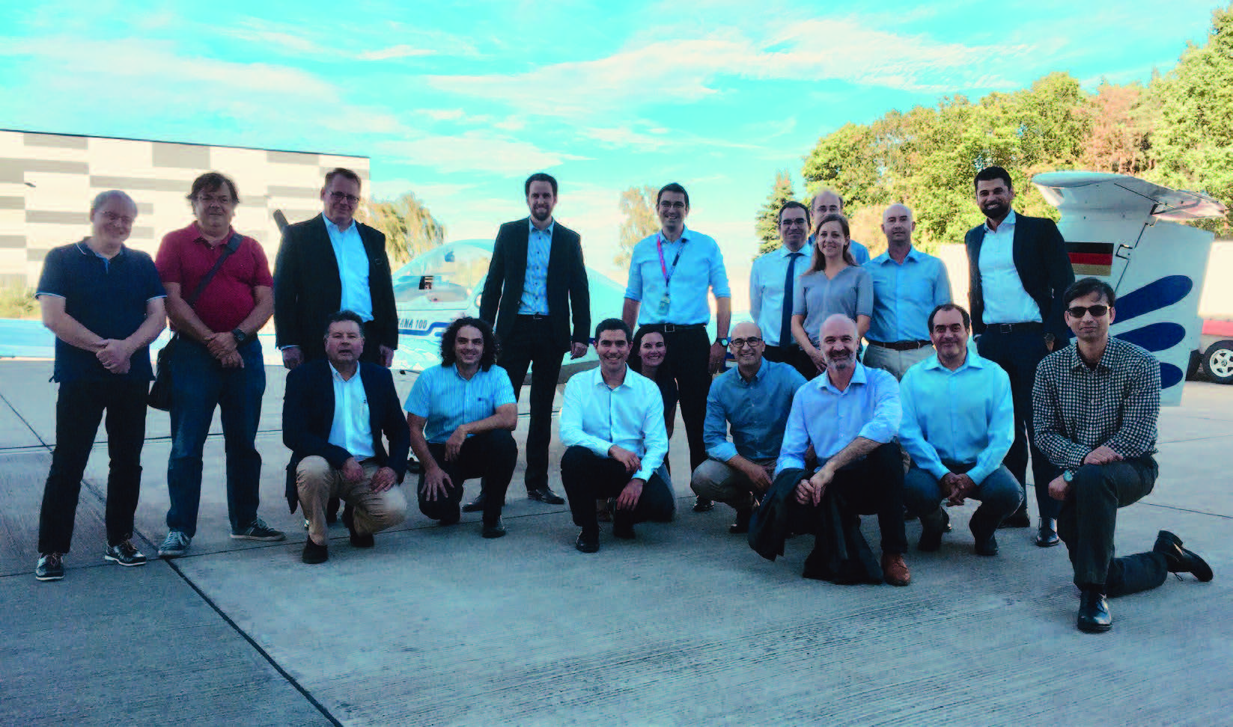

**Controlling the flow of air around an aircraft by making that flow laminar can reduce fuel-burn and cut emissions up to 10%. Clean Sky’s Hybrid Laminar Flow Control (HLFC) demonstrator is putting the theory to the test.**

Laminar flow is the Holy Grail for aerodynamicists, and in fluid dynamics laminar flow occurs when a fluid flows in parallel layers, with no disruption between the layers. Hybrid Laminar Flow Control, the subject of the HLFC Demonstrator project within Clean Sky 2’s Large Passenger Aircraft (LPA) Innovative Aircraft Demonstration Platforms (IADP), is a means to ensure that the air flows around certain parts of the aircraft in parallel layers using a hybrid structure which can be mounted on the leading edge of the tail and of the wing, and by so doing, significant fuel savings and environmental benefits are possible.

“Imagine if you light up a candle. The bottom part of the flame is quite stable, but the top of the flame moves erratically“ explains Xavier Hue - Clean Sky 2 Technical Leader at Airbus. “Think of laminarity as that lower, more stable part of the flame and contrast that with the top part of the flame which is “turbulent“, moving everywhere. If we transpose this comparison onto an aircraft the air around the wing behaves like the flame. There we want to reduce the turbulent part of the flow that is generating drag, which means more fuel consumption. What we’re aiming for is to have the air flow around the airfoil (it can be a wing and/or a vertical/horizontal tailplane) more like the stable, lower part of the flame. So what we’re trying to achieve with our HLFC system is to make sure we maintain the laminarity on the airfoil of the wing and/or the vertical/ horizontal tail plane for as long as possible, so that the air is flowing in parallel layers“. “Drag reduction by using laminar flow technology offers a potential double-digit decrease of specific fuel burn for large and faster long range aircraft. Suction will be applied at the leading edge of airframe components such as on the wing, tails or nacelles. The complexity, weight, industrial viability, and operability of the required systems are key to materialise the aerodynamic benefits“ says Hue.

The work package of the project will include two major ground-based demonstrators and one flight-test demonstration, which are complemented by research and windtunnel tests:

Demo 1 will focus on the development of HLFC horizontal tailplane and large-scale ground based testing to achieve a fully functional HLFC on a leading edge segment at TRL6. Demo 2 will include the design, build and test of a large-scale ground based demonstrator of HLFC technology applied on a wing at TRL4. A flight test demo to acquire data in specific flight conditions and representative of airlines operations will be carried out with an Airbus A320 reusing HLFC test fin developed in a former EU project.

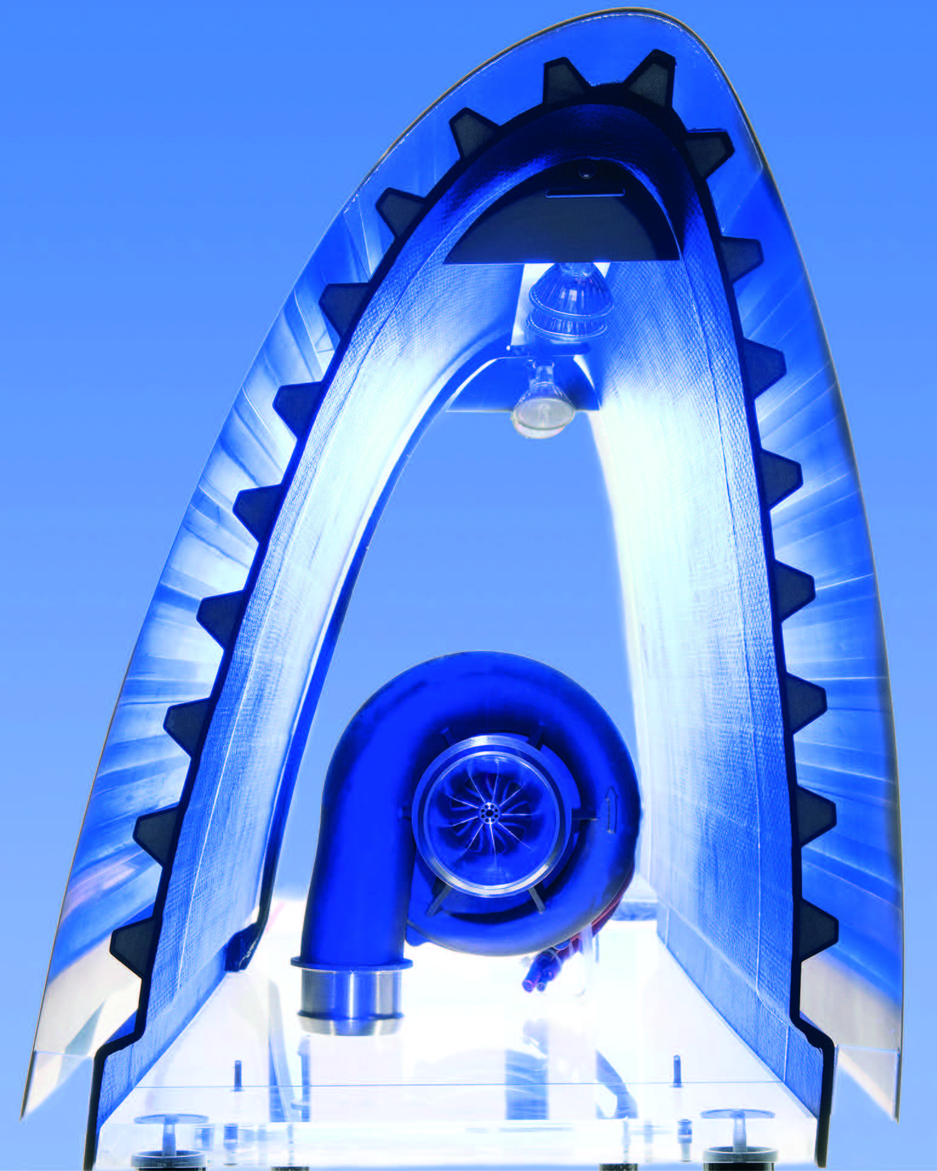

Sebastien Dubois, LPA Project Officer at Clean Sky reports that the project is now progressing towards developing a device which will be implemented to reinstate the laminarity of the air flow around the aircraft in order to avoid air turbulence: “Every time we go to reinstate such laminarity – either natural laminarity which means without any active devices, or using passive devices which is more linked to the shape of the product where we implement some active or passive devices to force the air-flow to become laminar – this will limit turbulence, contributing to fuel savings and reduction in CO2 emissions“ explains Dubois. To put the importance of this project to European aviation into a global context, he notes that “by comparison, overseas, a [hybrid laminarity] solution is already implemented on Boeing’s latest aircraft generation, the B787“.

What Clean Sky is doing in this project is to concentrate its efforts on implementing a solution on the aircraft empennage, focusing either on the fin (the vertical tailplane) or on the horizontal tailplane. A previous work-package within another EU project called AFLoNext already carried out studies on a fin – the project was completed last year with a solution flighttested on the DLR aircraft, showing a potential benefit of HLFC. Some of the findings of that project are complementary to Clean Sky 2’s Hybrid Laminar Flow Control project’s objectives, which aims at fuel reduction and CO2reduction of half of one percent.

Half a percent might not sound substantial, but the bigger objective of the project is to demonstrate the potential of the technology. This means carrying out the work associated with defining the device and the materials, performing the manufacturing of the demonstrators, and also conducting experiments, with the objective of collecting information around the constraints associated with the deployment and implementation of such a new device onto an aircraft.

“If we want to benefit from a positive exploitation route of such a solution we need to assess and process all the potential adverse elements such as constraints of cleaning, constraints of operation, potential failures that could occur in operation and so on. This could lead to the decision to implement – or even not to implement – such a solution. The idea is really to assess the potential performance in terms of benefits but also performance in terms of operations, to determine what is required to operate such a solution onto an aircraft, and this is what will take place in Clean Sky,“ says Dubois, who adds that “There are two aspects to all of this: the design, development and the maturation of the technologies, and the assessment of the in-flight performance and in operations, over a certain duration, to capture all the necessary elements“.

Though the project’s focal point is oriented around the aircraft tail, the ultimate goal is not to implement this on the empennage but on the wing, where most of the potential resides.

By the end of the project, the expectation is to accomplish HLFC demos on the tails & wing; manufacture of a segment of a Hybrid Laminar Flow Control Leading Edge (tested on a large scale ground test); development of a ’one shot’ process integrated with the micro-perforated Titanium sheet (developed in Clean Sky 2’s HYPERDRILL project); fulfillment of the aerodynamic, industrial and operability requirements; and a simplified HLFC concept for high production aircraft rate at acceptable cost.

“If you implement this everywhere on the wing and on the horizontal tailplane and the vertical tailplane you could gain up to 10% fuel efficiency“ says Airbus’s Hue, who points out that, in terms of progress, “there is a test pyramid planned, for which there are some samples already tested. Their evaluation is currently ongoing. Small scale demonstrators are being manufactured to secure and confirm the choice of the design solution. Achievements so far in the project include the completion of Demo 1, where the aeronautical and manufacturing requirements were consolidated with the system definition of the active/passive device, plus various coupon tests were passed, bringing the technology readiness level of the project to TRL3. Going forward, work started on Demo 2 in April 2018, and looking further into the horizon, the flight test demo is scheduled for 2019/2020“.